www.medicaljournalofcairouniversity.net

Accuracy of C-Arm Guided Insertion of Ommaya Reservoir Tube in Recurrent Cystic Craniopharyngiomas
MOHAMMED ADAWI, M.D.; MAHMOUD WAHDAN, M.D. and MOHAMMED MOURAD, M.D.
The Department of Neurosurgery, Faculty of Medicine, Benha University, Egypt

Abstract
Background: Caniopharyngiomas in spite of being benign tumors they have a high rate of recurrence of which cysts constitute major component. Ommaya Reservoir System (ORS) is a simple manoeuvre for percutaneous drainage of cysts.
Aim of Study: To evaluate the efficacy of using C-arm as a guiding tool for placement of Ommaya reservoir tube in predominantly cystic recurrent craniopharyngiomas.
Patients and Methods: This study included 8 patients with clinically symptomatic and radiologically confirmed recurrent craniopharyngioma with significant cystic part. These patients were treated by C-arm guided insertion of Ommaya reservoir tube. The technique is described in details. CT brain was obtained in the first post-operative night to assess the position of the tube. Post-operative clinical and radiological evaluations were compared to the pre-operative.
Results: This study included 6 males and 2 females, ranging in age from 5 years to 38 years with mean age of 18.4 years. Headache was the most common presenting complaint, followed by visual impairment. All surgeries were performed with C-arm guidance and post-operative CT brain documented satisfactory position of the tube in 7 cases and only one case required second look surgery for repositioning of the tube with the same technique. Significant post-operative improve- ment of headache and visual symptoms were encountered in all cases due to decompression of the optic chiasm by cyst drainage.
Conclusion: C-arm assisted insertion of Ommaya reservoir tube is a reliable method that can minimize the errors of free hand technique and of special value in low facility centers.
Key Words: Caniopharyngioma – Cyst – Ommaya reservoir.

Introduction
RECURRENCES of craniopharyngioma are a fact of life. The rate of recurrence may be as high as 40% in some series [1].

Correspondence to: Dr. Mohammed Adawi, The Department of Neurosurgery, Faculty of Medicine, Benha University, Egypt
One of the typical characteristics of craniophar- yngiomas is the presence of a cyst within the tumor. Such cysts occur in more than 90% of tumors and often the cyst comprises the major component of the tumor [2].

The goal of surgery is decompression of the optic and ventricular pathways. For primarily cystic tumors, drainage and injection of radioactive iso- topes or a chemotherapeutic agent may be an al- ternative to surgical resection [3].

First described in the 1960s, Ommaya reservoir placements have various applications, most notably allowing ventricular access for sampling and ther- apy in cancer [4].

Recurrent lesions with significant cystic com- ponent not amenable to total extirpation may be treated by repetitive aspirations through an ind- welling Ommaya reservoir apparatus [5].

Ventricular catheter placement associated with an Ommaya reservoir has been accomplished by several techniques over the years. A freehand catheter technique was used initially, but over the years has been largely supplanted by various forms of image guidance as technology has improved and practitioners have recognized that freehand placement was associated with a high rate of failure [6].

Patients and Methods

Eight cases with recurrent cystic craniopharyn- gioma were treated by inserting Ommaya reservoir system for cyst drainage in Benha University Hos- pital between March 2016 and October 2018. In- formation on clinical manifestation, histopathology, surgical technique, and outcome was obtained by

1651

review of the patient charts and radiological reports. Follow-up was available from4-18 months.

Surgical technique:
The patient is placed supine with the head in a neutral position over a radiolucent table. By using CT brain with reformatting, relation of the cyst to the anterior and posterior clinoid processes in the antero-posterior plane, as well as its relation to the frontal crest and crista galli in the lateral plane, are studied and documented. The distance between
the outer table of the frontal bone and the basal part of the cyst is also documented to identify the ideal length of the tube. Relying on these bony landmarks, the C-arm is used to guide the insertion of the tube in the operative theater Fig. (1).

After confirming the target position of the tube, the stylet is removed and very small volume of cyst fluid is withdrawn, then final assembly of the system is performed by connecting the tube to the side of the reservoir Fig. (2).

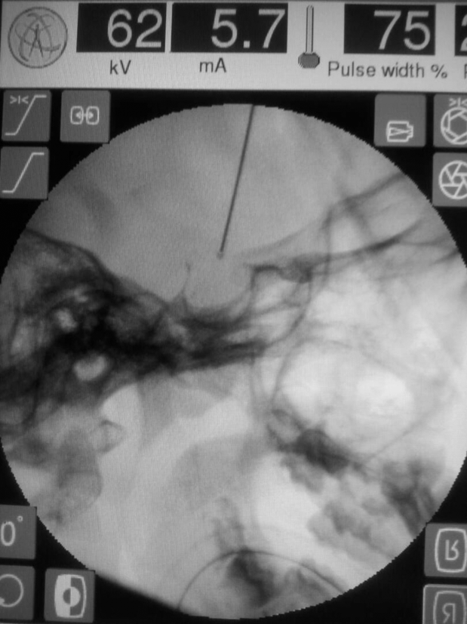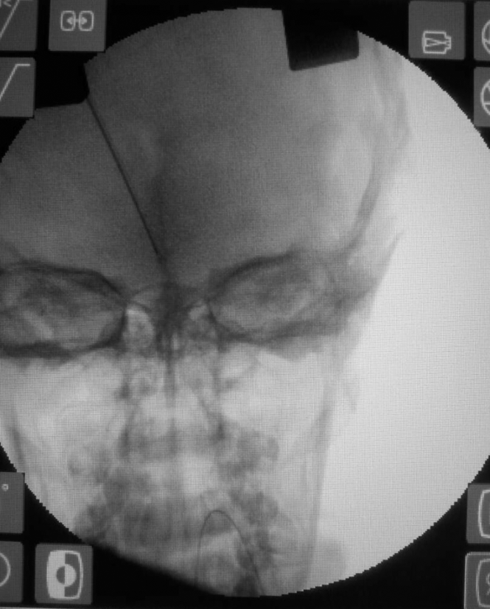Fig. (1): Intra-operative C-arm images
(A)
(B)
- Lateral view showing the target end of the tube tip behind and just above the anterior clinoid (to be in the center of the cyst and just above its bottom), (B) Antero- posterior view showing the distal end of the tube in the medline.

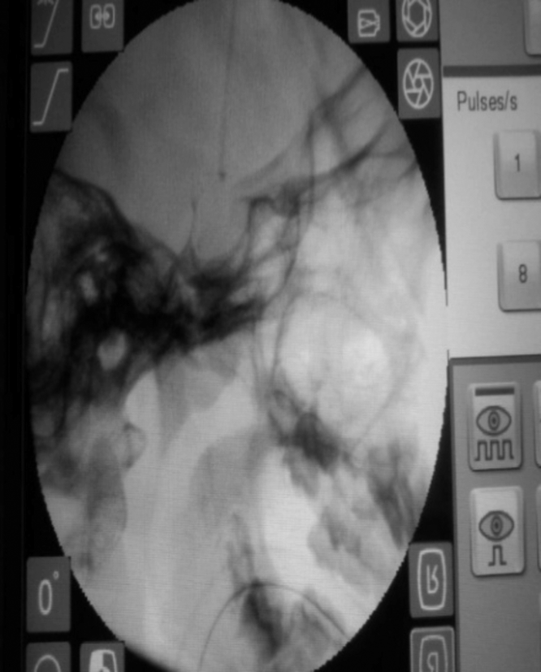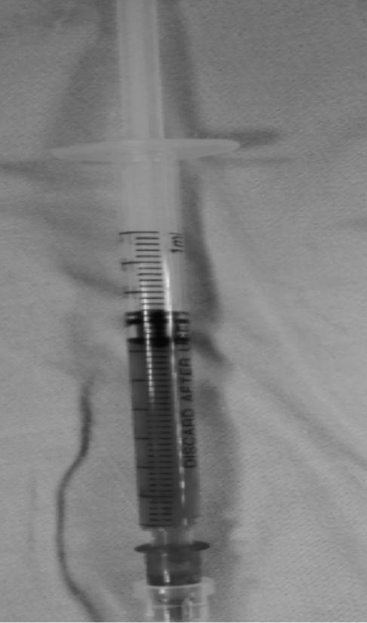Fig. (2): (A) Lateral view by the C-arm showing the final tube position after removal of the stylet, (B) Characteristic craniopharyngioma fluid.
(A)
(B)

Results
Six patients were males, and 2 were females. The ages ranged from 5 years to 38 years with mean age of 18.4 years. At admission, headache was the most frequent presentation in all patients, followed by visual manifestations in 7 patients.
All included cases were treated by inserting Ommaya reservoir tube using the described tech-
nique. Post-operative CT brain documented accept- ed position of the tube end in all except one case that required second look surgery by the same technique Fig. (3).

Significant post-operative improvement of head- ache and visual symptoms were encountered in all cases due to decompression of the optic chiasm by cyst drainage Fig. (4).

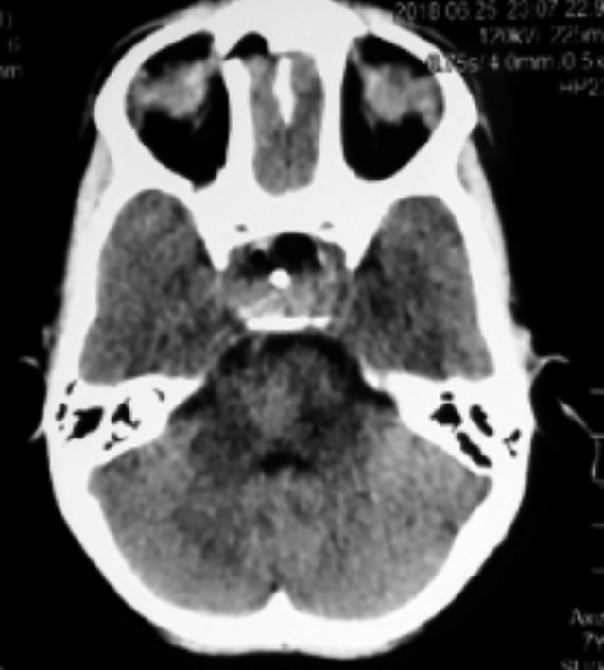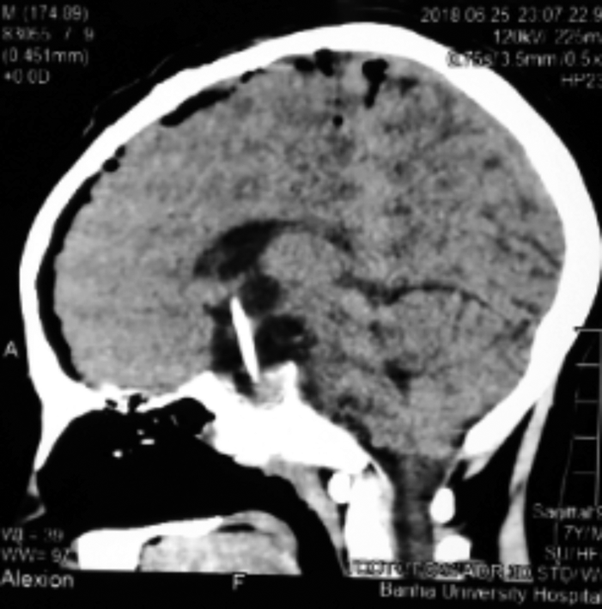Fig. (3): First day post opera- tive CT brain of 5 years old boy showing accepted tube position in
(A)
(B)
  - 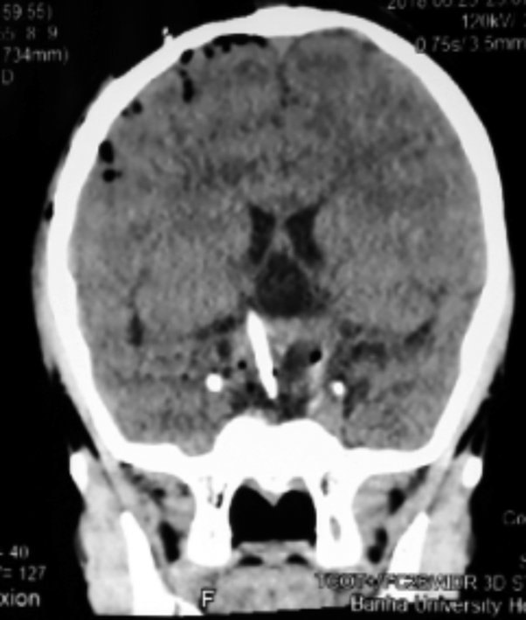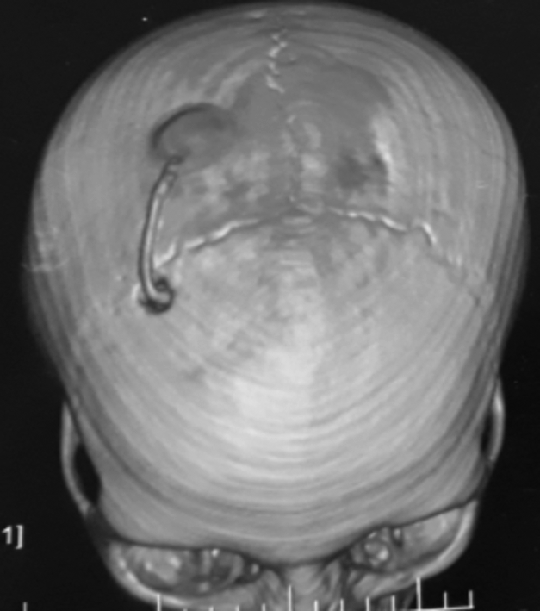Axial plane, (B) Sagittal plane,
(C)
(D)
(C) Coronal plane, and (D) 3D reformatting showing the position of the burr hole and the connection of the tube to the reservoir.

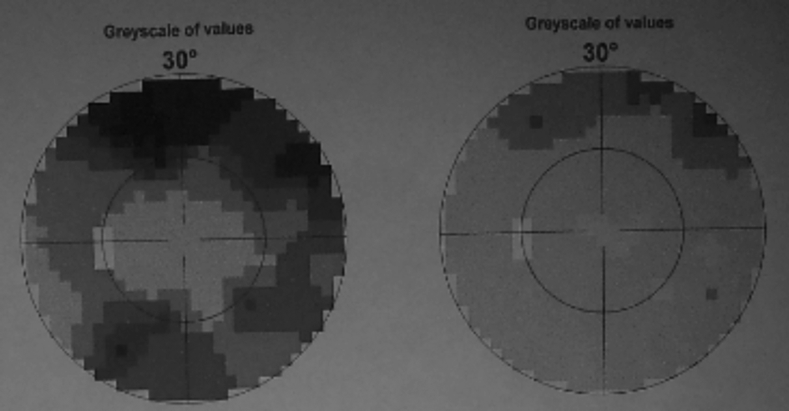
(A)

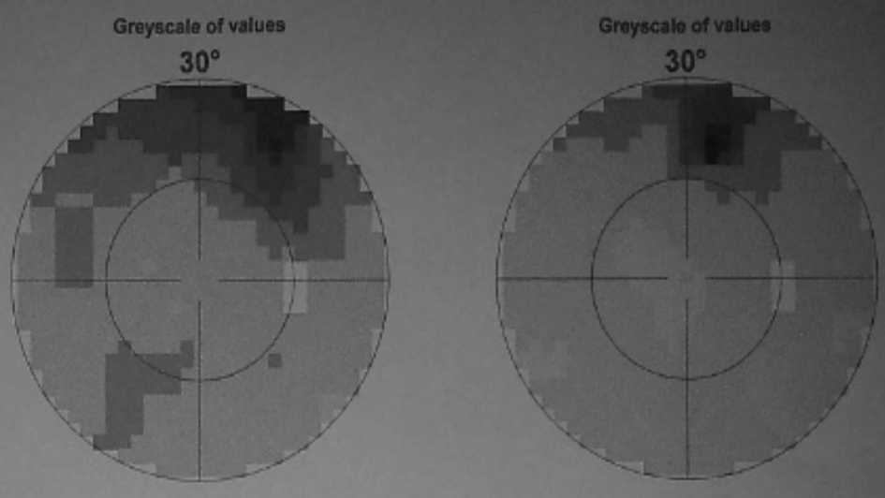
(B)
Fig. (4): Visual field examination for 35 years, female patient treated by the described maneuver. (A) Visual field of the left eye: Pre-operative field "left image" with dramatic improvement in post-operative assessment "right image". (B) Visual field of the right eye: Pre-operative field "left image" with improvement in post-operative assessment "right image".

Discussion
Craniopharyngiomas (CPs) are benign, slow growing tumors whose ideal management remains controversial and challenging. They arise from remnants of the craniopharyngeal duct and/or Rathkes cleft. These tumors have an incidence of between 1.2% and 4.6%, with a bimodal age dis- tribution, one peak occurring in children and the other in adults between the 4th and 6th decades. These tumors are located close to the visual appa- ratus, hypothalamus, pituitary stalk, 3rd ventricle, and vasculature from the circle of Willis [1].
The Ommaya reservoir is used widely in neuro- oncology, primarily for the instillation of intrathecal chemotherapy and frequent CSF tapping in patients with CNS disease [7]. We used the ommaya reser- voir to continuously drain the cystic component of craniopharyngiomas.
Ommaya reservoir placement is frequently a procedure performed in very ill patients with late stage disease, in whom minimizing anesthesia and operative time is important for reducing peri- operative risk. Before the advent of neuronavigation using infrared and other tracking modalities, fluor-

oscopy was available to monitor catheter placement intraoperatively [8].
We consider that fluoroscopic guidance was associated with safety and simplicity on top of acceptable accuracy.
Much of the evidence regarding image guidance for ventricular catheter placement is found in the literature describing ventricular shunt procedures. It has been well established that using image guid- ance to place a ventricular catheter results in more accurate catheter placement than by a freehand technique [8,9]. By using the same principle we could place the catheter directly in the cystic component of craniophayngioma but depending on the bony fixed structures found near the supra- sellar area. So, it's not affected by errors that may occur with navigator after egress of some cyst fluid (brain shift like).
In order to assess the accuracy of catheter placement, we relied on two parameters first is the position of the catheter inside the craniopharyngi- oma cyst and the steadiness of the fluid coming through the catheters.
Complications related to Ommaya reservoir placement such as infection or mal-positioning of the catheter are rare, but can have significant consequences in an already compromised patient population [10-12]. We had a case with misplaced catheter required second look surgery for reposi- tioning of the tube with the same technique. There was no morbidity as it didn't injure any of the important structures in the nearby area with minimal flow as the tube was touching the cystic component and drained some of the retained fluid.
Patients were referred to Gamma Knife after ensuring adequate cyst drainage.
We found that this technique is valuable as it enables the surgeon to directly visualize the termi- nation point of the catheter to the desired location at the end of the procedure, allowing for small adjustments prior to departing from the operating room and obtaining the post-operative CT scan.
Conclusion:
We can conclude that this technique can be used safely and effectively for placement of the
catheter tip of the Ommaya reservoir in acceptable location and do not require rigid fixation of the head.

References
- RUTKA J.T.: Endonasal resection of Craniopharyngiomas.
J. Neurosurg., 109: 1-5, 2008.
- STEINBOK P. and HUKIN J.: Intracystic treatments for craniopharyngioma. Neurosurg. Focus., 28 (4): E13, 2010.
- GOTTFRIED O.N., COULDWELL W.T. and WEISS
M.H.: Tumors of the Sellar Region: Craniopharyngioma and Pituitary Adenoma. In: Baehring JM, Piepmeier JM (eds): Brain Tumors Practical Guide to Diagnosis and Treatment. New York, Informa Healthcare, 20: 353-75, 2007.
- OMMAYA A.K.: Subcutaneous reservoir and pump for sterile access to ventricular cerebrospinal fluid. Lancet, 2 (7315): 983-4, 1963.
- SPAZIANTE R., IRACE C. and De DIVITIIS E.: Brach-
ytherapy of cystic craniopharyngiomas. J. Neurosurg., 79: 966-7, 1993.
- WEINER G.M., CHIVUKULA S., CHEN C.J., DING D.,
ENGH J.A. and AMANKULOR N.: Ommaya reservoir with ventricular catheter placement for chemotherapy with frameless and pinless electromagnetic surgical neu- ronavigation. Clinical Neurology and Neurosurgery, 130: 61-6, 2015.
- McDERMOTT M.W., CIRICILLO S.F., GUTIN P.H. and
EDWARDS M.S.: Stereotactic insertion of an ommaya reservoir: Technical note. Can J. Neurol. Sci., 22 (3): 235-8, 1995.
- WILSON T.J., STETLER W.R., AL-HOLOU W.N. and
SULLIVAN S.E.: Comparison of the accuracy of ven- tricular catheter placement using freehand placement, ultrasonic guidance, and stereotactic neuronavigation. Journal of Neurosurgery, 119 (1): 66-70, 2013.
- LEVITT M.R., O'NEILL B.R., ISHAK G.E., et al.: Image-
guided cerebrospinal fluid shunting in children: Catheter accuracy and shunt survival. J. Neurosurg. Pediatr., 10 (2): 112-7, 2012.
- SANDBERG D.I., BILSKY M.H., SOUWEIDANE M.M.,
BZDIL J. and GUTIN P.H.: Ommaya Reservoirs for the Treatment of Leptomeningeal Metastases. Neurosurgery, 47 (1): 49-55, 2000.
- PERRIN R.G., LISHNER M., GUHA A., CURTIS J.,
FELD R. and MESSNER H.: Experience with Ommaya reservoir in 120 consecutive patients with meningeal malignancy. Can. J. Neurol. Sci., 17 (2): 190-2, 1990.
- PEYRL A., CHOCHOLOUS M., AZIZI A.A., et al.: Safety
of Ommaya reservoirs in children with brain tumors: A 20-year experience with 5472 intraventricular drug ad- ministrations in 98 patients. J. Neurooncol., 120 (1): 139-
45, 2014.

